PROBLEM STATEMENT: 2

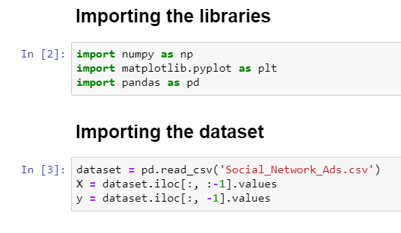

First we are importing the libraries that is required for the program. Then import the dataset.

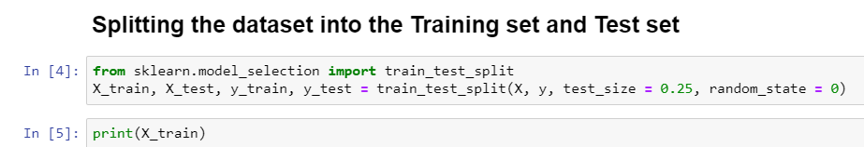

Next, we split the dataset into the training set and test set. Then print the train set.



Print the training set for the variable y.



Print the test set for the variable X.



Print the test set for the variable y.

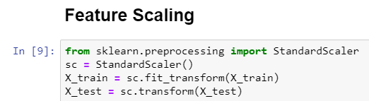

Next perform the feature scaling for transforming. Then print the test and training set for the variable X.

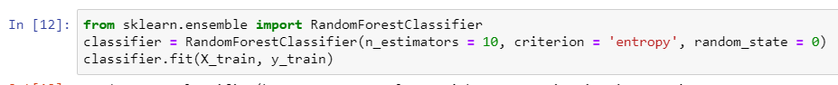

Then we are performing the Random Forest classification model for the training set.

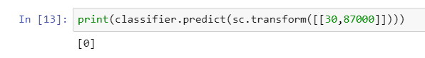

Print the predicted value for the classifier.

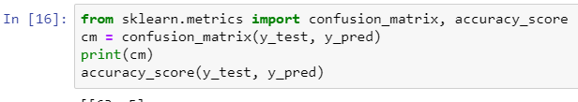

Then perform the confusion matrix to calculate the accuracy score.

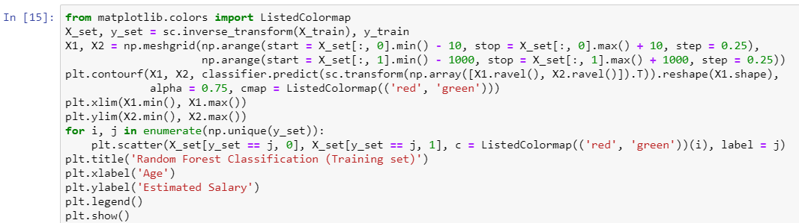

Visualize the training set result.